**SemanticFusion: Dense 3D Semantic Mapping with Convolutional Neural Networks**

**Abstract**

**Semantics(CNN)**

**ElasticFusion**

**25Hz**

**I.Introduction**

**SLAM+CNN**

**UYUv2**

**II.Related work**

**大概是其他人做的一些工作**

**III.Method**

**Composed of three separate units:**

1. **SLAM system**
2. **CNN**
3. **Bayesian update schema**

**Details:**

1. **SLAM mapping**

**Twc**

1. **CNN architecture**

**Caffe**

1. **Incremental semantic label fusion**

C:\Users\95720\AppData\Roaming\Tencent\Users\957207396\TIM\WinTemp\RichOle\ZS])P@1@GZTXG]YBS{0L2QH.png

1. **Map Regularisation**

**Energy E(x) consists of two parts**

1. **the unary data term**
2. **the pairwise smoothness term**

**(看不懂的公式)**

C:\Users\95720\AppData\Roaming\Tencent\Users\957207396\TIM\WinTemp\RichOle\NG2[_H88R)EG83QBJE0FL@B.png

C:\Users\95720\AppData\Roaming\Tencent\Users\957207396\TIM\WinTemp\RichOle\`J]R%95O8`4TYJ[S{(K8]3T.png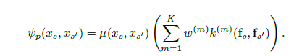

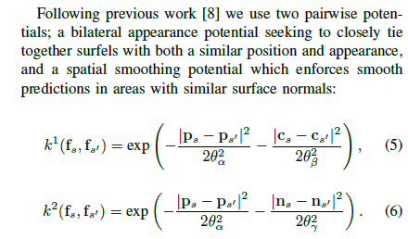

**IV.Experiments**

1. **Network Training**
2. **Reconstruction Dataset**
3. **CNN,CRF update frequency experiments**

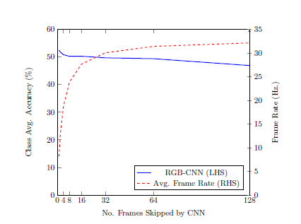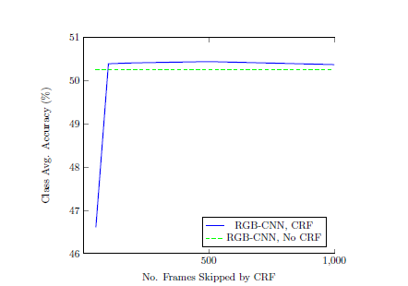

1. **Accuracy Evaluation**
2. **NYU dataset**

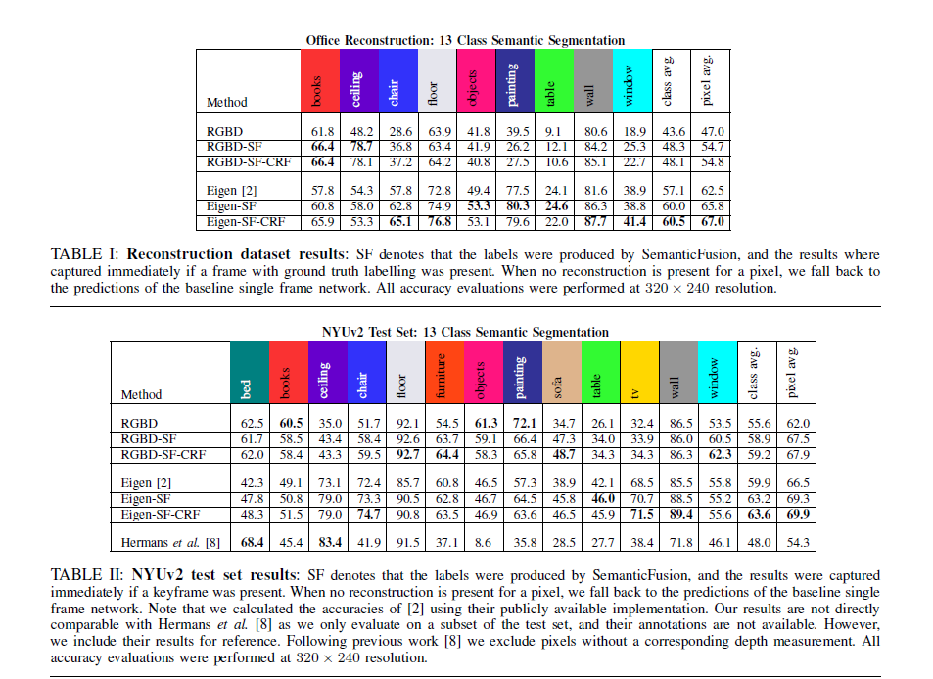

1. **Run-time performance**

**V.Conclusions**

**好像意思就是他们的东西在数据集上精度提高了，是可以用的，以及对SLAM++的一些展望。**

**找到一个很好的论文解析：https://blog.csdn.net/Crazydogg/article/details/82669949**